30.23: a) 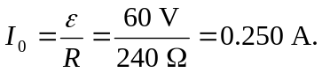
b)
c) and c is at the higher potential.
d)

